**Visualizing and Predicting Heart Diseases with an Interactive Dash Board**

**TEAM ID:** PNT2022TMID28768

**PROBLEM SOLUTION FIT**

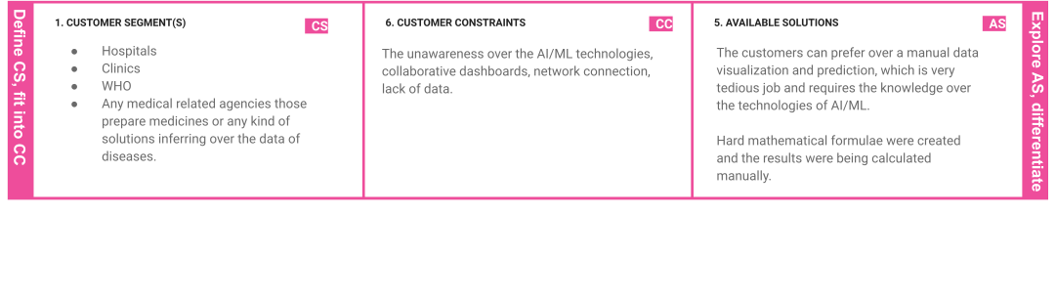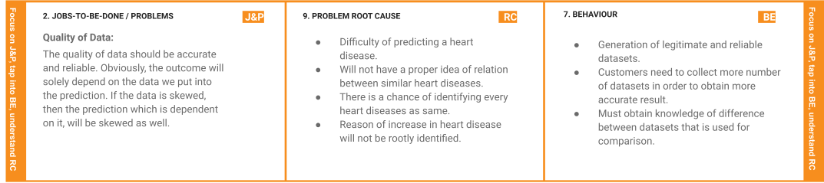

|  |  |  |  |  |  |  |  |
| --- | --- | --- | --- | --- | --- | --- | --- |
|  |  | | | **10. YOUR SOLUTION SL**  With the notable technology of AI/Ml we are able to visualize and predict heart diseases and related diseases, by the ultimate power Cognos Analytics Tool we will be able to properly create a dashboard for the customers to work with and visualize and analyze the heart disease on their work with limited knowledge. | **8.CHANNELS of BEHAVIOR**  **8.1 ONLINE**  Visualizing the datasets. Exploration of data.  **8.2 OFFLINE**  Cleansing of datasets.  Collection and noting the datasets. | **CH** |  |
| **3. TRIGGERS**   * Insufficient ways of handling huge amounts of datasets and inferring the root cause of the heart disease cannot be found out. * Similarity of heart disease has not been identifiable. | **TR** |  |  |
|  |
|  |  | | |  |  |  |  |